TASK#1:

#include<iostream>
using namespace std;

void display_menu()
{

cout << "Fitness Menu "<< endl;;

cout << "Price for joining is $15.00 " << endl;

cout << "Senior Citizen discount will be 30%" << endl;

cout << "If the membership has paid for 12 months or more, there is 15% discount" << endl;

cout << "If more than 5 personal training sessions are paid for, there is 20% discount" << endl;
}

double ask_user(double price)

{

char senior,twelveormore,training;

price = 15.00;

cout << "Are you a senior citizen? " << endl;

cin >> senior;

if(senior == 'Y')
{

cout <<"Senior discount applied "<<(price*.3)<<" Removed from cost" <<endl;

price=price-(price*.3);
}

cout<<"Have you paid for more than 12 months?" << endl;

cin>>twelveormore;

if(twelveormore == 'Y'){

cout <<"12 month discount applied "<<(price*.15)<<" Removed from cost" <<endl;

price=price-(price*.15);}

cout << "Have you received more than 5 personal training sessions? " << endl;

cin >> training;

if(training == 'Y')
{

cout <<"Trainer discount applied "<<(price*.2)<<" Removed from cost" <<endl;

price=price-(price*.2);
}

return price;

}

int main()

{

double price;

display_menu();

ask_user(price);

cout << "Price will be: " << price << endl;

return 0;
}
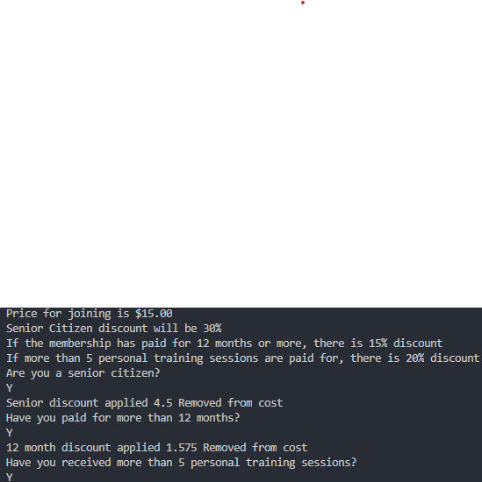

TASK#2:

#include<iostream>
using namespace std;

bool Cheak_leap_year(int year)
{
if((year%4==0)&&(year%100!=0)||(year%400==0))
{
return true;

}

else{
return false;

}

}

int main()
{
int year;
cout<<"Enter a year:";
cin>>year;
Cheak_leap_year(year);
cout<<Cheak_leap_year(year)<<endl;
return 0;
}

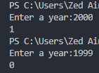
TASK#3:

#include<iostream>
using namespace std;
float temp_celsius(float celsius)
{float fahrenheit;
celsius=(fahrenheit-32)*0.556;
return celsius;
}

float temp_fahrenheit(float fahrenheit )
{ float celsius;
fahrenheit = (celsius * 1.8) + 32;
return fahrenheit;
}

int main()
{
float fahrenheit, celsius;

cout<<"Enter the value of celsius:";
cin>>celsius;
temp_fahrenheit(celsius );
cout<<"Celsius converted into fahrenheit:"<<temp_fahrenheit(celsius )<<endl;
cout<<"Enter the value of fahrenheit:";
cin>>fahrenheit;
temp_celsius(fahrenheit);
cout<<"farhenheit conveted into celsius"<<temp_celsius(fahrenheit)<<endl;
return 0;
}

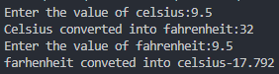
TASK#4:

#include<iostream>
#include<ctime>
using namespace std;

const int LOTTERY_NUMBERS = 5;
void sortRandomLottoNumbers(int list[], int listLength)
{
int temp;
int location;
int smallIndex;

for (int i=0; i<listLength-1; i++)
{
smallIndex = i;
for (location=i+1; location<listLength; location++)
if (list[location] < list[smallIndex])
smallIndex = location;

temp = list[smallIndex];
list[smallIndex] = list[i];
list[i] = temp;
}

cout << "After sorting lottery numbers are:" << endl;
for (int i=0; i<listLength; i++)
cout << list[i] << " ";
cout << endl << endl;
}
int main()
{
int lottoNum[LOTTERY_NUMBERS];
int playerNum[LOTTERY_NUMBERS];
char decide;
int counter;

cout << "********** LOTTERY GAME **********" << endl << endl;
cout << "Do you want to play lottery (Enter Y for Yes and N for No): ";
cin >> decide;
cout << endl;

while (decide == 'Y' || decide == 'y')
{
srand(time(0));
cout << "Generated lottery numbers: ";
for (int i=0; i<LOTTERY_NUMBERS; i++)
lottoNum[i] = rand() % 39 + 1;
for (int i=0; i<LOTTERY_NUMBERS; i++)
cout << lottoNum[i] << " ";
cout << endl << endl;
sortRandomLottoNumbers(lottoNum, LOTTERY_NUMBERS);
cout << "Pick 5 numbers between 1 & 40: ";
for (int i=0; i<LOTTERY_NUMBERS; i++)
cin >> playerNum[i];
cout << endl;

counter=0;
for (int i=0; i<LOTTERY_NUMBERS; i++)
{
for (int j=0; j<LOTTERY_NUMBERS; j++)
if (playerNum[i] == lottoNum[j])
counter++;
}

if (counter==5)
cout << "You Win !" << endl << endl;
else
{
cout << "You Lose !" << endl;
cout << "The winning numbers are: ";
for (int i=0; i<LOTTERY_NUMBERS; i++)
cout << lottoNum[i] << " ";
cout << endl << endl;
}

cout << "Do you want to play lottery (Enter Y for Yes and N for No): ";
cin >> decide;
cout << endl;
}

return 0;
}

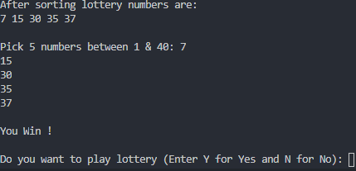
TASK#5:

#include<iostream>
using namespace std;

float scale(float magnitude)
{

if(magnitude<2.0)
{
cout<<magnitude<<"with magnitude"<<""<<"Earthquake is considered to be a Micro earthquake. "<<endl;
}
else if(magnitude<3.0&&magnitude>2.0)
{
cout<<magnitude<<"with magnitude"<<""<<"Earthquake is considered to be a Very minor earthquake. "<<endl;
}
else if(magnitude>3.0&&magnitude<4.0)
{
cout<<magnitude<<"with magnitude"<<""<<"Earthquake is considered to be a Very minor earthquake. "<<endl;
}
else if(magnitude>4.0&&magnitude<5.0)
{
cout<<magnitude<<"with magnitude"<<""<<"Earthquake is considered to be a Very Light earthquake. "<<endl;
}
else if(magnitude>5.0&&magnitude<6.0)
{
cout<<magnitude<<"with magnitude"<<""<<"Earthquake is considered to be a Moderate earthquake. "<<endl;
}
else if(magnitude>6.0&&magnitude<7.0)
{
cout<<magnitude<<"with magnitude"<<""<<"Earthquake is considered to be a Strong earthquake. "<<endl;
}
else if(magnitude>7.0&&magnitude<8.0)
{
cout<<magnitude<<"with magnitude"<<""<<"Earthquake is considered to be a Major earthquake. "<<endl;
}
else if(magnitude>8.0&&magnitude<10.0)
{
cout<<magnitude<<"with magnitude"<<""<<"Earthquake is considered to be a Great earthquake. "<<endl;
}
else if(magnitude>=10.0)
{
cout<<magnitude<<"with magnitude"<<""<<"Earthquake is considered to be a Meteoric earthquake. "<<endl;
}
return magnitude;
}
int main()
{
float a;
cout<<"Enter the magnitude"<<endl;
cin>>a;
scale(a);
return 0;

}

